Assignment #1

Harmeet kaur

8665061

21 may,2019

**SENG8030**

**Testing Tools**

**Assignment #1: Rubric**

|  |  |  |  |  |
| --- | --- | --- | --- | --- |
| **#** |  | **Mark** | **Weight** | **Criteria** |
|  |  |  |  | **New Defect Logging [75 Marks]** |
|  | **1.** |  | **5** | New defect ID being provided for each defect |
|  |  |  |  |  |
|  | **2.** |  | **5** | Title correctly and uniquely identifying each defect |
|  |  |  |  |  |
|  | **3.** |  | **10** | Description of each defect is correct and clearly outlines the defect |
|  |  |  |  | and how to reproduce it. |
|  | **4.** |  | **10** | Expected Results are correct for each defect |
|  |  |  |  |  |
|  | **5.** |  | **10** | Actual Results are correct for each defect |
|  |  |  |  |  |
|  | **6.** |  | **10** | Severity is correctly assigned for each defect |
|  |  |  |  |  |
|  | **7.** |  | **5** | Checkbox for Reproducible correct for each defect |
|  |  |  |  |  |
|  | **8.** |  | **5** | Application information is correct for each defect |
|  |  |  |  |  |
|  | **9.** |  | **5** | Environment information is correct for each defect |
|  |  |  |  |
|  |  |  |  |  |
|  | **10.** |  | **5** | Submitted by is correct for each defect |
|  |  |  |  |
|  |  |  |  |  |
|  | **11.** |  | **5** | Date provided is correct for each defect |
|  |  |  |  |  |
|  |  |  |  | **Penalties** |
|  |  |  | **-0.50 each** | **Standards deductions (i.e. spelling mistakes, naming).** |
|  |  |  | **-15** | **Late submission (per day)** |
|  |  |  | **-7.5** | **Missing documentation or not in correct order** |
|  |  |  |  |  |
|  |  |  | **75** | **Total Marks** |

|  |  |
| --- | --- |
| **Defect #1** | **Title: Run-time error ‘6’: overflow** |
| **Description:** System is getting crashed when clicking on “OK” button of popped up message run-time error 6 overflow when entering more than 4 digits in both the text boxes. | |
| **Expected Results:** | “Please input an integer value between -99 and 99 only“ pop-up message should be displayed and home page should be displayed after clicking on ok button |
| **Actual Results:** | “Run-time error’6’: overflow” pop-up message is displayed and application is getting crashed after clicking on ok or close” X” sign button. |
| **Reproducible?** | 1. Enter value > 4 digits in first box. 2. Enter value >4 digits in second box. 3. Click on “Add ‘Em Up” button. |
| **Application:** | ProSum |
| **Environment Used:** | Microsoft Windows 10 |
| **Version #:** | 1.0 |
| **Severity:** | 1-Critical |
| **Date Submitted:** | 5/18/2019 |
| **Submitted By:** | Harmeet kaur |

|  |  |
| --- | --- |
|  |  |

|  |  |
| --- | --- |
| **Defect #2** | **Title: Accepting decimal value and giving wrong output** |
| **Description:** As per requirement mentioned in about only integer values should be accepted but application is accepting decimal values and displaying wrong output | |
| **Expected Results:** | A pop-up message “Please input an integer value between -99 and 99 only” should be displayed when entering any value except integers. |
| **Actual Results:** | Decimal values accepted and wrong output is displayed after adding decimal numbers. |
| **Reproducible?** | 1. Enter two numbers with decimal values 2. Click on “Add’Em UP” button |
| **Application:** | ProSum |
| **Environment Used:** | Microsoft Windows 10 |
| **Version #:** | 1.0 |
| **Severity:** | 2-High |
| **Date Submitted:** | 5/18/2019 |
| **Submitted By:** | Harmeet kaur |

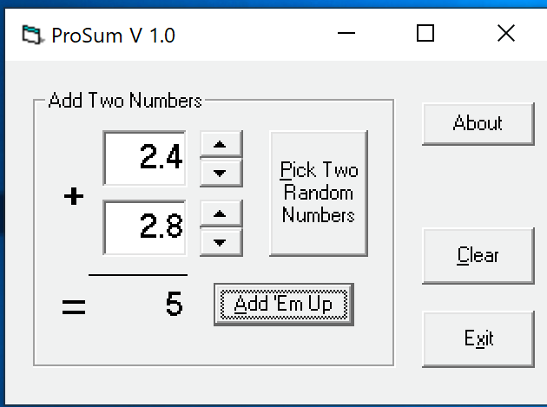

|  |  |
| --- | --- |
| **Defect #3** | **Title: Pop up message when entering value within the requirement** |
| **Description:** When clicking on” Add‘Em up” button after entering -99 as one input and 0 as second input then pop-up message “Please input an integer value between -99 and 99 only“ is getting displayed. | |
| **Expected Results:** | Both the integers should be added and -99 as a result. |
| **Actual Results:** | A pop-up message “Please input an integer value between -99 and 99 only is getting displayed. |
| **Reproducible?** | 1. Enter -99 in first input box and 0 in second input box. 2. Press “Add’Em up “button. |
| **Application:** | ProSum |
| **Environment Used:** | Microsoft Windows 10 |
| **Version #:** | 1.0 |
| **Severity:** | 2-High |
| **Date Submitted:** | 5/18/2019 |
| **Submitted By:** | Harmeet kaur |

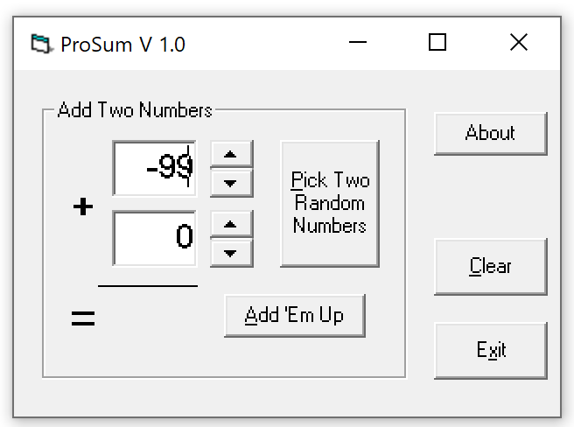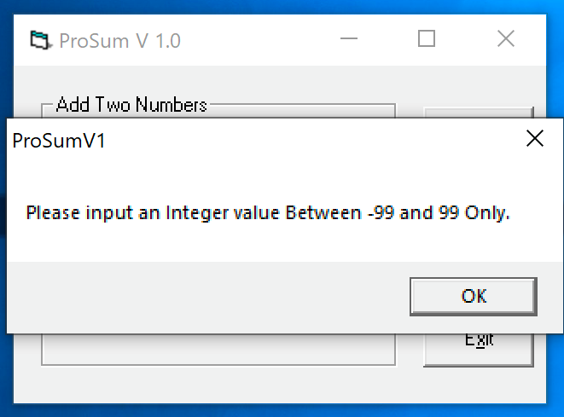

|  |  |
| --- | --- |
| **Defect #4** | **Title: Message displayed entering values within -99 to 99** |
| **Description:** Displaying pop-up message on entering correct values as -99 and -99 in both input boxes respectively. | |
| **Expected Results:** | Both numbers should be added up correctly. |
| **Actual Results:** | A pop-up message “Please input an integer value between -99 and 99 only “is displayed. |
| **Reproducible?** | 1. Enter both input integers with value -99 and -99. 2. Click on “Add’Em Up” button. |
| **Application:** | ProSum |
| **Environment Used:** | Microsoft Windows 10 |
| **Version #:** | 1.0 |
| **Severity:** | 2-High |
| **Date Submitted:** | 5/19/2018 |
| **Submitted By:** | Harmeet kaur |

|  |  |
| --- | --- |
|  |  |

|  |  |
| --- | --- |
| **Defect #5** | **Title: Picking special character “()“ and getting wrong output by adding** |
| **Description:** when giving positive integer input with brackets in both input boxes and clicking on “Add’Em Up” is displaying incorrect value instead of pop-up message. | |
| **Expected Results:** | A pop-up message “Please input an integer value between -99 and 99 only “is displayed. |
| **Actual Results:** | Special character () are accepted and wrong output is displayed. |
| **Reproducible?** | 1.Enter two positive integers within brackets in both input fields.  2.Click on “Add’Em Up” bjutton. |
| **Application:** | ProSum |
| **Environment Used:** | Microsoft Windows 10 |
| **Version #:** | 1.0 |
| **Severity:** | 2-High |
| **Date Submitted:** | 5/19/2019 |
| **Submitted By:** | Harmeet kaur |

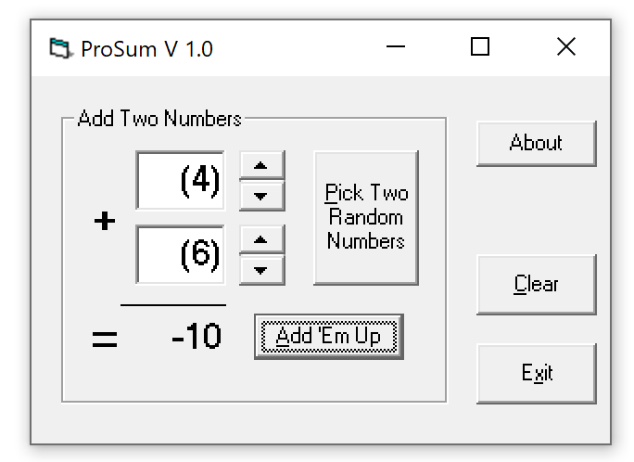

|  |  |
| --- | --- |
| **Defect #6** | **Title: -100 value is popping up in second textbox.** |
| **Description:** -100 value is popping up in the second textbox when clicking on the down button from “up/down” button option and as per requirement value should be between -99 and 99. | |
| **Expected Results:** | Value should be displayed between -99 and 99. |
| **Actual Results:** | -100 is getting displayed. |
| **Reproducible?** | Click on the down button in the empty second textbox up-to the last integer i.e. -100 Or directly press down button from keyboard and continue the process until -100. |
| **Application:** | ProSum |
| **Environment Used:** | Microsoft Windows 10 |
| **Version #:** | 1.0 |
| **Severity:** | 3-Moderate |
| **Date Submitted:** | 5/19/2018 |
| **Submitted By:** | Harmeet kaur |

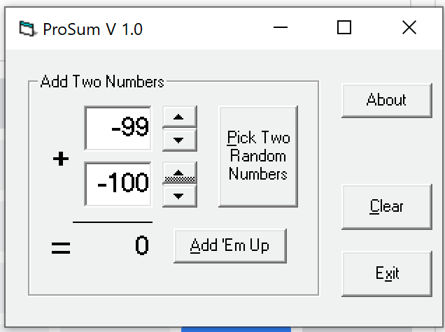

|  |  |
| --- | --- |
| **Defect #7** | **Title: Four buttons with same functionality** |
| **Description:** All the four buttons in the About dialog has the same functionality of exiting the dialog when clicked which is inconsistent and not user friendly. | |
| **Expected Results:** | Functionality should be different for all the four buttons or one button is sufficient for exiting the dialog. |
| **Actual Results:** | Exiting the dialog when clicking on any of the four buttons. |
| **Reproducible?** | Click on about button and then click on any of the four buttons. |
| **Application:** | ProSum |
| **Environment Used:** | Microsoft Windows 10 |
| **Version #:** | 1.0 |
| **Severity:** | 3-Moderate |
| **Date Submitted:** | 5/20/2019 |
| **Submitted By:** | Harmeet kaur |

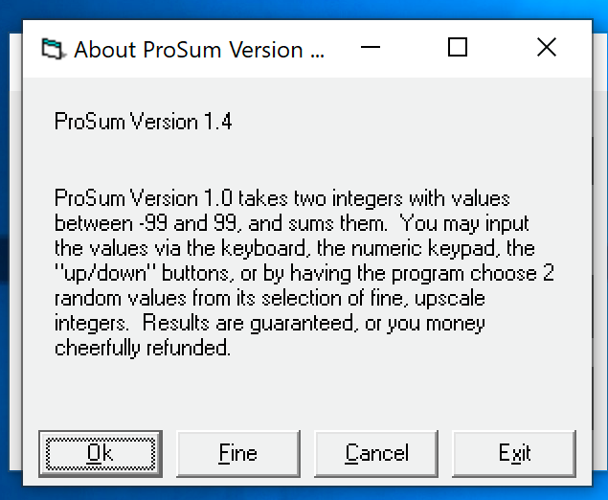

|  |  |
| --- | --- |
| **Defect #8** | **Title: Invalid integer value showing up for “pick Two Random Numbers” button.** |
| **Description:** when clicking on “Pick Two Random Numbers” button value 100 is showing up in the input box. | |
| **Expected Results:** | Values should be in between -99 and 99 only. |
| **Actual Results:** | 100 value is showing up. |
| **Reproducible?** | click multiple times on “Pick Two Random Numbers”. |
| **Application:** | ProSum |
| **Environment Used:** | Microsoft Windows 10 |
| **Version #:** | 1.0 |
| **Severity:** | 3-Moderate |
| **Date Submitted:** | 5/20/2019 |
| **Submitted By:** | Harmeet kaur |

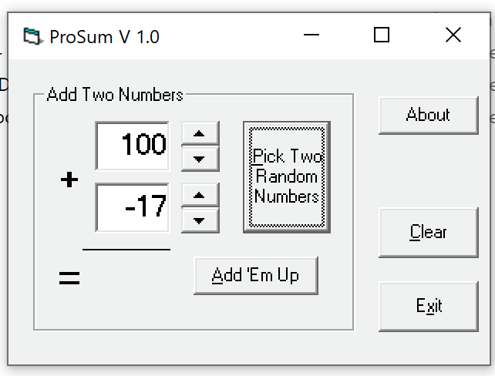

|  |  |
| --- | --- |
| **Defect #9** | **Title: ProSum application versions mentioned is inconsistent** |
| **Description:** ProSum application has different versions mentioned in the below fields which is inconsistent:  About: ProSum Version 1.4 and in the description ProSum version 1.0.  Pop-Up message- ProSumV1 | |
| **Expected Results:** | Application version should be same at all the places. |
| **Actual Results:** | Different versions in the fields. |
| **Reproducible?** | 1. Launch the prosum application 2. Check the name on the name bar 3. Click on the about button and check the version on name bar and in the description 4. Input wrong data and check the version in pop up message |
| **Application:** | ProSum |
| **Environment Used:** | Microsoft Windows 10 |
| **Version #:** | 1.0 |
| **Severity:** | 4-Low |
| **Date Submitted:** | 5/20/2019 |
| **Submitted By:** | Harmeet kaur |

|  |  |
| --- | --- |
|  |  |

|  |  |
| --- | --- |
| **Defect #10** | **Title: Up/down buttons doesn’t work properly after using clear button** |
| **Description:** Up/down button is picking up next integer value from the last entered value when clicking on clear button after adding 2 integer valuesin both the fields. | |
| **Expected Results:** | When the input boxes are clear it should start with number zero when those buttons are used. |
| **Actual Results:** | Next integer value is getting popped after clearing the data from both the fields. |
| **Reproducible?** | 1. Enter any integer in first textbox 2. Enter any integer in second textbox 3. Click on Add’Em Up button 4. Click on clear button. 5. Click on up/down button. |
| **Application:** | ProSum |
| **Environment Used:** | Microsoft Windows 10 |
| **Version #:** | 1.0 |
| **Severity:** | 4-Low |
| **Date Submitted:** | 5/20/2019 |
| **Submitted By:** | Harmeet Kaur |

|  |  |
| --- | --- |
| **Defect #11** | **Title: Sequence of tab button movement not sequential** |
| **Description:** Tab button is not sequentially going to “Add’Em up” button after clicking on “pick two random numbers” button, instead it moves to about button. | |
| **Expected Results:** | After clicking on “pick two random numbers” button, the tab button should take the curser to “Add’Em Up” button. |
| **Actual Results:** | Tab button is moving the cursor to “About” button. |
| **Reproducible?** | Click on tab button multiple times on keyboard |
| **Application:** | ProSum |
| **Environment Used:** | Microsoft Windows 10 |
| **Version #:** | 1.0 |
| **Severity:** | 5-Feature Enhancement |
| **Date Submitted:** | 5/20/2018 |
| **Submitted By:** | Harmeet kaur |

|  |  |
| --- | --- |
| **Defect #12** | **Title: Spelling, grammar and stylistic problems** |
| **Description:** There are multiple spelling, grammar and stylistic problems with the text on below dialogs and buttons which is inconsistent:   1. Pop-Up message-Caps in the sentence like Integer, Between and Only) 2. About button description-Grammatical and spelling mistakes 3. Add ‘Em up button- Stylistic font and underlined only first alphabet. 4. Clear, exit, fine and ok buttons- Underlined only 1 alphabet in each button. | |
| **Expected Results:** | Spelling and grammar should be correct and in the same format for all the fields. |
| **Actual Results:** | Multiple spelling, grammar and stylistic problems. |
| **Reproducible?** | Click on about button and check pop-up message by giving wrong input values. |
| **Application:** | ProSum |
| **Environment Used:** | Microsoft Windows 10 |
| **Version #:** | 1.0 |
| **Severity:** | 5-Feature Enhancement |
| **Date Submitted:** | 5/20/2019 |
| **Submitted By:** | Harmeet Kaur |

|  |  |  |  |
| --- | --- | --- | --- |
|  |  |  |  |

|  |  |
| --- | --- |
| **Defect #13** | **Title: Maximize button will only maximize the frame** |
| **Description:** The maximize button only maximize the outer frame of the application, whereas the whole application with buttons stays at the left top corner. | |
| **Expected Results:** | Will full screen the whole application with maximizing the buttons and tabs. |
| **Actual Results:** | Maximizing only the outer frame whereas the buttons and input boxes remains the same in size and remains at the left top corner. |
| **Reproducible?** | Click on the maximize button on the top right corner, in between minimize and close button |
| **Application:** | ProSum |
| **Environment Used:** | Microsoft Windows 10 |
| **Version #:** | 1.0 |
| **Severity:** | 5-Feature Enhancement |
| **Date Submitted:** | 5/20/2019 |
| **Submitted By:** | Harmeet kaur |

